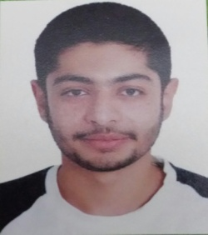

**Curriculum Vitae**

***Personal Information:***

Name: Ahmed Fadhel Ahmed

Nationality: Bahraini

Date of Birth 19 Dec, 1992

Marital Status: Single

***Educational Qualifications:***

2010 -2015 University of Bahrain

B.Sc.in Physical Education

2007 – June 2010 Sh.AbdulAziz Secondary

High school-Business(75%)

***Other Qualifications****:*

December 2010 University of Bahrain

Macromedia Flash CS4

***Work Experience***:

July 2008 Al-Adhari Park

***Personal skills:***

* Good in Microsoft Word,Access,Excel,Power Point.
* Fast learning and can work under pressure.
* Hardworking and confident.
* Innovative and dynamic.
* Commitment on time.
* Positive relationship building and team working.
* Good in sales and business
* Responsible and considerate
* Friendly and adaptable

***Interests and Hobbies***:

* Searching Online
* Football
* Swimming
* Reading
* Basketball
* Watching Movies

***Languages:***

Arabic & English (Read,Write,Understand and Speak)

***Honors and Awards***:

* Delegate in Meet ICT Bahrain 2012 conference
* IT Symposium 4 (IT GOES GREEN)

***References***: Available Request

***Contact* Information**

***Mobile Phone***:(+973) 36788114

***E-Mail***: ahmedf2092@gmail.com